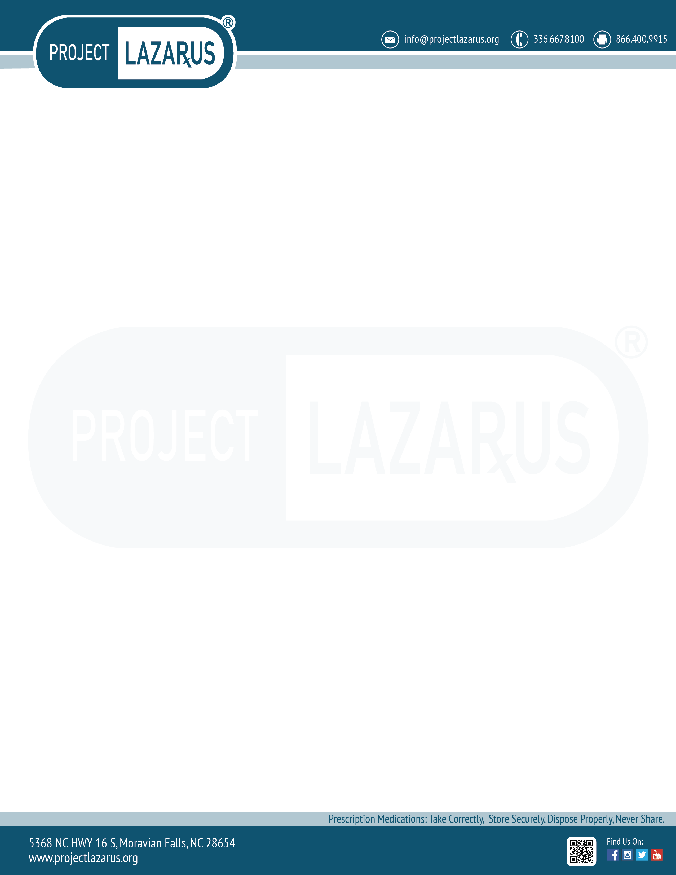

**North Carolina Disposal Initiative (NCDI)**

***Grant Instructions***

**Introduction and Statement of Purpose**

Medicine take back events are an important way to raise awareness for the need to properly store and dispose of prescription medicines. Take back events destroy thousands of doses of unused, unwanted and expired medications each year, thereby reducing the risk of diversion and misuse.

Congratulations and thank you for being part of the NCDI. You have received a grant to help you organize and promote a take back event in your community. The grant funds are also intended to help you measure the results of your efforts. Careful measurement of results is critical to demonstrate the value of take back events, and to ensure that they continue in the future.

Grants may be used for:

* + Education and promotional material
  + Signage for take-back events
  + Media advertising
  + Stipends for community leaders, law enforcement, or pharmacy personnel
  + Storage of collected medicines
  + Transportation of collected medicines
  + Destruction of collected medicines
  + Bins for take-back events
  + Other (please specify)

All NCDI data will be collected through MOSAIX’s IMPACTLITE+ (IMPACT) application at <www.plimpact.onmosaix.com>.

IMPACT is a tool that helps manage the activities of Communities. You will also collect data on all of your Community’s Planned Events, including the place and time of each event including any promotional materials that will be used to promote the take back event or drop box activities.

We are also asking that you submit data regarding your Community Health Needs Assessment as well as your Coalition Member information.

You will also collect data on all of your Community’s Planned Events, including the place and time of each event including any promotional materials that will be used to promote the take-back event or drop box activities.

**Next Steps**

1. **Register your event**

You will register the place and time of your event(s) in IMPACT at [www.plimpact.onmosaix.com](http://www.plimpact.onmosaix.com). You register an event, you’ll use the “Planned Events” section under the Planning menu in IMPACT. For step by step instructions for how to register an event please review the IMPACT Guidance Document.

1. **Promote your event**

If you need assistance in obtaining or creating promotional or advertising material, Operation Medicine Drop and Project Lazarus have many resources. Please visit [www.NCSafeKids.org](http://www.NCSafeKids.org) or [www.ProjectLazarus.org](http://www.ProjectLazarus.org) for more information.

You can use the grant money to print and copy the promotional material, and/or purchase advertising in local newspapers.

You will submit all promotional material that was used to promote either your events or drop boxes under the “Promotional Materials” section the Planning menu in IMPACT. Please upload copies of all of the promotional materials utilized by your Community. For step by step instructions, please review the IMPACT Guidance Document.

1. **Prepare to measure your results**

Make sure the onsite team at the take back event has access to the following:

* A scale to weigh the collections
* A series of bins (at least 5) to sort the following collections:
  + opioids
  + benzodiazepines
  + stimulants
  + other prescription medicine
  + all other collections (OTC, vitamins, etc.).
* Access to a “pill identification” program,

such as <https://www.drugs.com/pill_identification.html>

* Copies of the Reporting Forms (Appendix 1), in either electronic or hard copy format
* You will submit your results under then Record Data section of IMPACT. For step by step instructions, please review the IMPACT Guidance Document.

**Points of Contact**

Should you have any questions or need clarification, please contact Project Lazarus at 336-667-8100 or [NCDI@projectlazarus.org](mailto:NCDI@projectlazarus.org).

**Thank you for taking the time to decrease diversion, as well as misuse and abuse, of prescription medication in your community.**

Appendix 1: Reporting Forms

**North Carolina Disposal Initiative (NCDI)**

General Instructions:

Make sure you have the following equipment before you start:

* A scale to weigh the collections
* A series of bins (at least 5) to sort the following collections:
  + opioids
  + benzodiazepines
  + stimulants
  + other prescription medicine
  + all other collections (OTC, vitamins, etc.).
* Access to a “pill identification” program,

such as <https://www.drugs.com/pill_identification.html>

* Copies of the Reporting Forms (Appendix 1), in either electronic or hard copy format

Recording Instructions:

As medicine and drugs are droppoed off, please follow these instructions:

1. Record information about Prescription (Rx) medicine on the Prescription Medicine Tally Sheet
   1. Record all available information
   2. If the medicine is returned with the prescription label, all required information can be found on that label
   3. If medicine is returned without the prescription label, such as in a plastic bag, try to identify the medication and indicate the quantity returned
2. Record information about non-Prescription (over-the-counter) medicine on the Non-Prescirption Medicine Tally Sheet
   1. Only the name of the produce is required for non-prescription medicines
3. After recording the medicine information, place the medicine into the appropriate bin:
   * opioids only
   * benzodiazepines only
   * stimulants only
   * other prescription medicine (not opioid, benzodiazepines or simulants)
   * all other collections (OTC, vitamins, etc.)
4. It is OK in desposit pill bottles, blister packs and original medicine packaging (such as containers and boxes) into the bins. DO NOT include other trash (such as bags andflyers) into the bins.







Electronic Version of the Reporting Forms can be found here:

